Database Soal Kewirausahaan UNW00007

**DAFTAR ISI**

SOAL UJIAN MID SEMESTER 2009/2010 ................................................................................................... 3 SOAL UJIAN MID SEMESTER 2010/2011 ................................................................................................... 4 SOAL UJIAN AKHIR SEMESTER ....................................................................................................................... 5 SOAL UJIAN AKHIR SEMESTER 2006/2007 .............................................................................................. 6 SOAL UJIAN AKHIR SEMESTER 2007/2008 .............................................................................................. 7 SOAL KEWIRAUSAHAAN .................................................................................................................................... 8 SOAL UJIAN TENGAH SEMESTER 2011/2012 ......................................................................................... 9

SOAL UJIAN TENGAH SEMESTER 2013/2014 ....................................................................................... 10 SOAL UJIAN TENGAH SEMESTER 2014/2015 ....................................................................................... 11 SOAL UJIAN TENGAH SEMESTER 2017/2018 ....................................................................................... 12 SOAL UJIAN TENGAH SEMESTER 2018/2019 ....................................................................................... 13 SOAL AKHIR TENGAH SEMESTER 2018/2019 ...................................................................................... 14 SOAL UJIAN TENGAH SEMESTER 2019/2020 ....................................................................................... 15

DIKLAT HMIF Page 2

Database Soal Kewirausahaan UNW00007

**SOAL UJIAN MID SEMESTER 2009/2010**

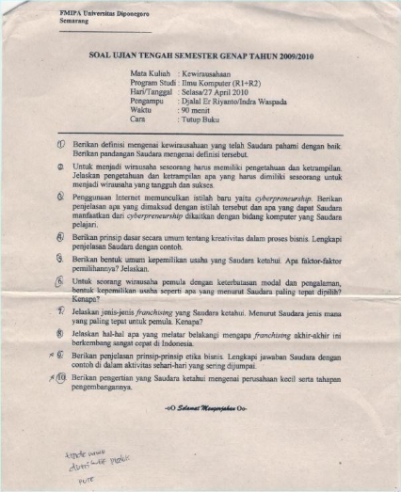DIKLAT HMIF Page 3

Database Soal Kewirausahaan UNW00007

**SOAL UJIAN MID SEMESTER 2010/2011**

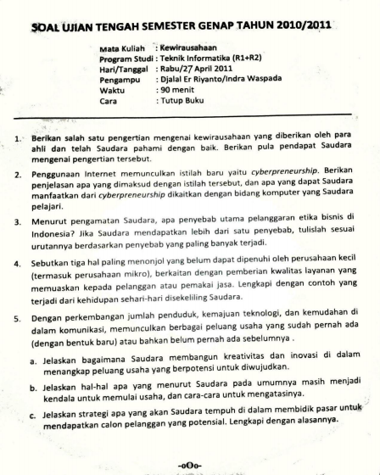DIKLAT HMIF Page 4

Database Soal Kewirausahaan UNW00007

**SOAL UJIAN AKHIR SEMESTER**

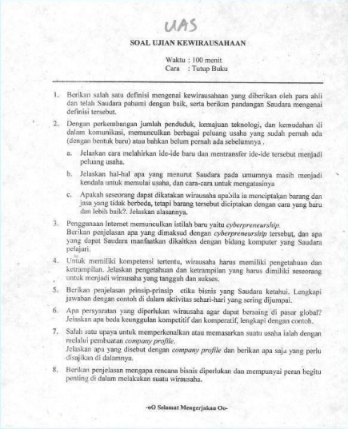DIKLAT HMIF Page 5

Database Soal Kewirausahaan UNW00007

**SOAL UJIAN AKHIR SEMESTER 2006/2007**

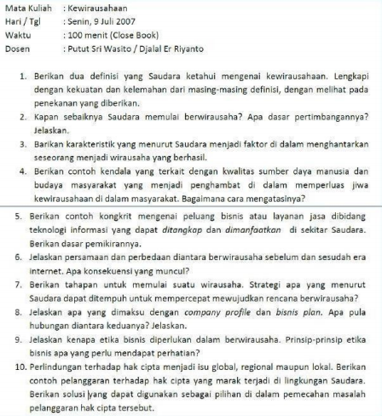DIKLAT HMIF Page 6

Database Soal Kewirausahaan UNW00007

**SOAL UJIAN AKHIR SEMESTER 2007/2008**

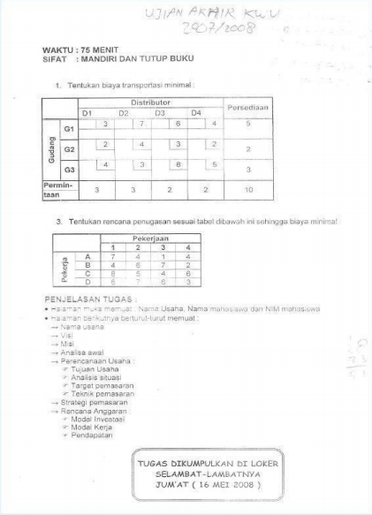DIKLAT HMIF Page 7

Database Soal Kewirausahaan UNW00007

**SOAL KEWIRAUSAHAAN**

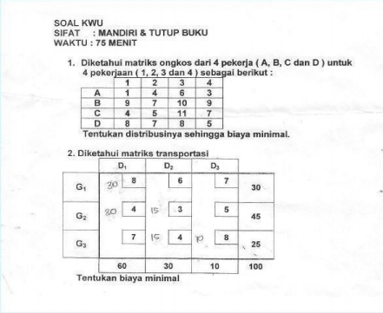DIKLAT HMIF Page 8

Database Soal Kewirausahaan UNW00007

**SOAL UJIAN TENGAH SEMESTER 2011/2012**

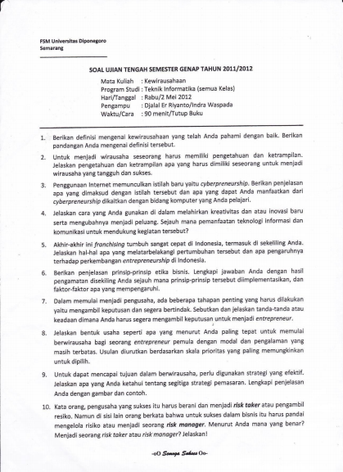DIKLAT HMIF Page 9

Database Soal Kewirausahaan UNW00007

**SOAL UJIAN TENGAH SEMESTER 2013/2014**

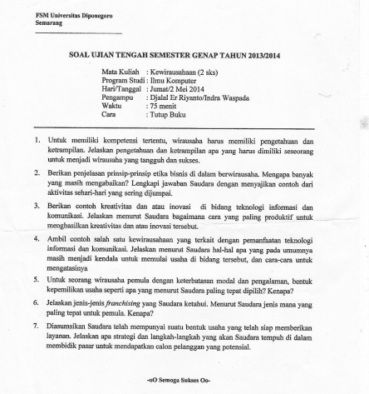DIKLAT HMIF 10

Database Soal Kewirausahaan UNW00007

**SOAL UJIAN TENGAH SEMESTER 2014/2015**

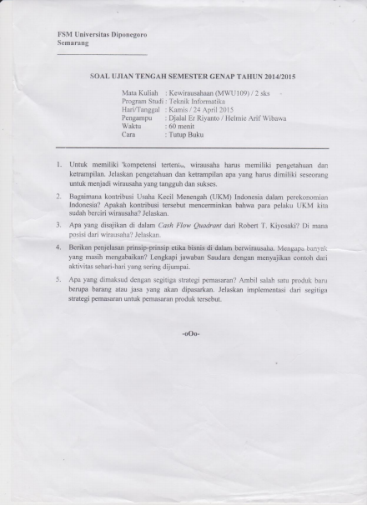DIKLAT HMIF 11

Database Soal Kewirausahaan UNW00007

**SOAL UJIAN TENGAH SEMESTER 2017/2018**

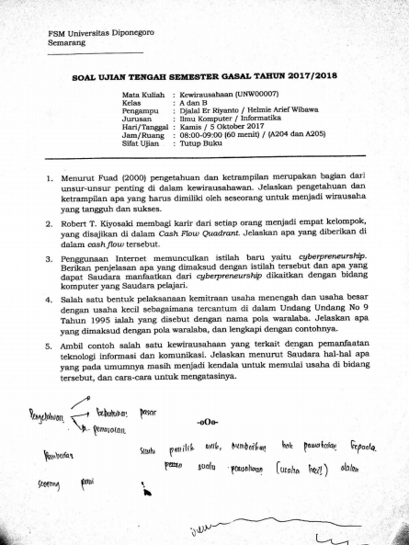DIKLAT HMIF 12

Database Soal Kewirausahaan UNW00007 **UJIAN TENGAH SEMESTER 2018/2019**

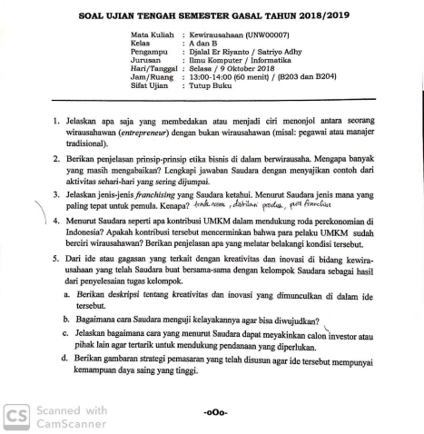DIKLAT HMIF 13

Database Soal Kewirausahaan UNW00007 **UJIAN AKHIR SEMESTER 2018/2019**

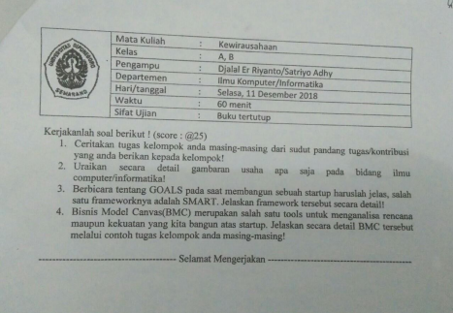DIKLAT HMIF 14

Database Soal Kewirausahaan UNW00007

**UJIAN TENGAH SEMESTER 2019/2020**

DIKLAT HMIF 15